Chapter 18, Solution 44.

If the rectangular pulse in Fig. 18.46(a) is applied to the circuit in Fig. 18.46(b), find v_{o} at t = 1 s.

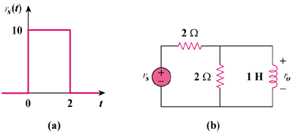

Figure 18.46
For Prob. 18.44.

Solution

1H jω

We transform the voltage source to a current source as shown in Fig. (a) and then combine the two parallel 2Ω resistors, as shown in Fig. (b).

(a)

2

I_{o}

+

V_{o}

−

jω

V_{s}/2

2

1

I_{o}

+

V_{o}

−

jω

V_{s}/2

(b)

Hence

1.839 V

